As A/An | I want to | So that | Acceptance Criteria
Pilots & Co-Pilots | Login to the system | The system can authenticate me | Successful login shows assigned flights
 | View assigned  flights | I can prepare for  upcoming flights | Dashboard shows flight list with time & route
 | Update flight status | Passengers and operators get real-time updates | Flight status change updates notifications
 | Complete digital safety checklist | Flights meet safety standards | System stores checklist & prevent takeoff without  completion
 | Submit post-flight log | Records stay updated | System confirms log saved successfully
 | Receive weather  alerts | I can avoid dangerous  conditions | Weather warnings appear instantly
 | Report emergency | Emergency team can respond | Emergency alert triggers SOS workflow
 | Logout | My account remains secure | System logs me out & clears session
System Admin | Login securely | I can manage the platform | Two-factor authentication required
 | Manage users | Only verified users access the system | Admin can approve, suspend, or remove accounts
 | Configure routes & pricing | Configure routes & pricing | Updated route visible immediately
 | Monitor system performance | I can ensure the app runs smoothly | Dashboard shows uptime, errors, alert
 | Manage helipad locations | Users get correct pickup points | Helipad list updates across system
 | Handle customer support tickets | Issues get resolved quickly | Ticket status updates (Open/In Progress/Resolved)
 | View logs & audit  trails | System stays secure | All activities recorded  with timestamp
 | Logout | Account remains safe | System ends session
Helicopter Service Provider | Login | I can access the  operator dashboard | Successful login  verification
 | Manage helicopter  availability | Passengers can book  available flights | Updated availability  shows immediately
 | Assign pilots to flights | Flights operate smoothly | Assigned pilots receive notifications
 | Upload documents  (insurance, license) | System stores required  compliance documents | Upload success  confirmation
 | View maintenance log | I ensure helicopter health | Logs displayed with dates & actions
 | Monitor fuel usage | I can control cost | Fuel reports auto generated
 | Track flights | I know operational  status | Real-time map display
 | Process corporate bookings | Large groups can travel | Booking details shown clearly
 | Logout | Accounts stay protected | Session cleared safely

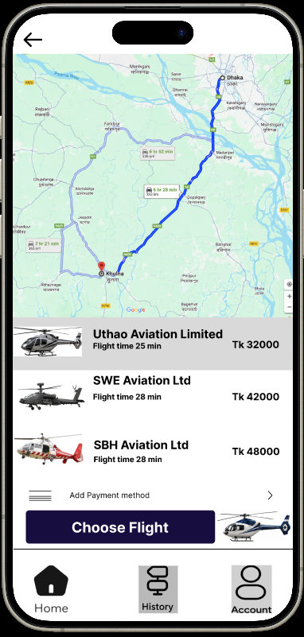
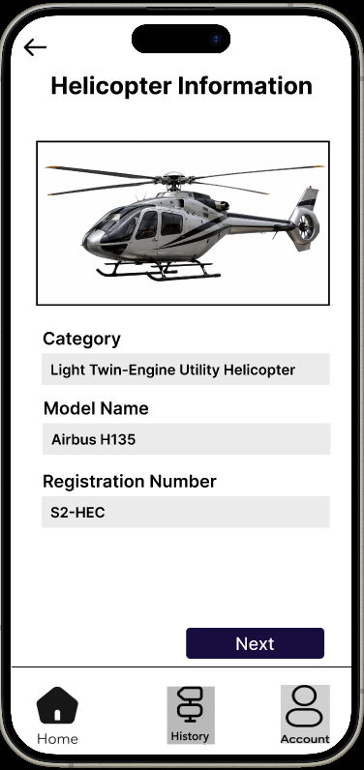
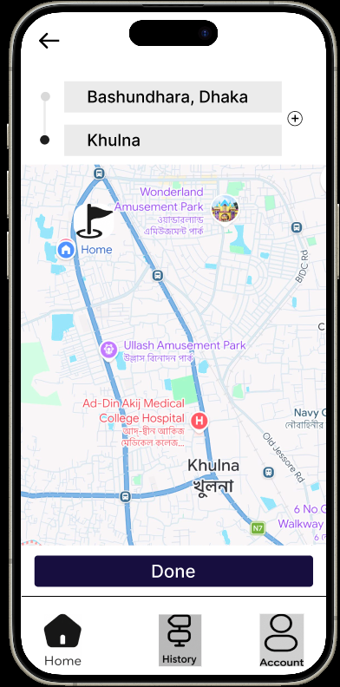
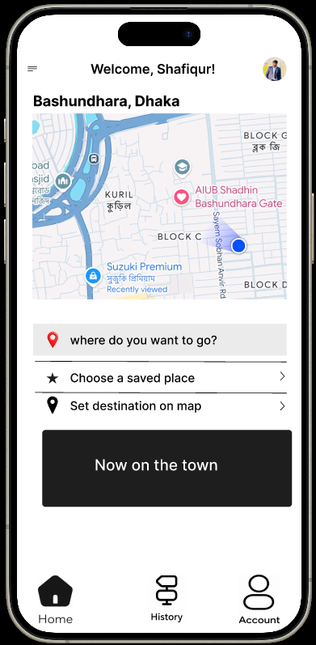
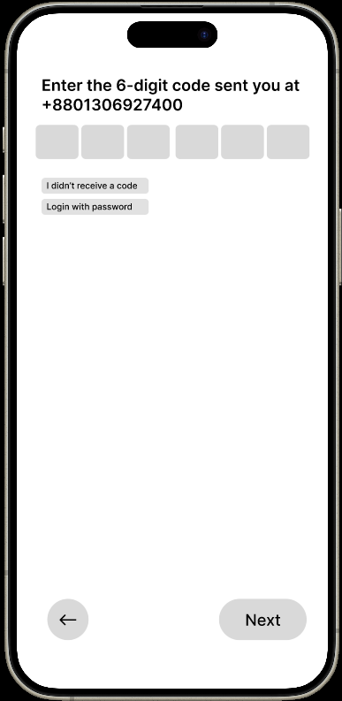
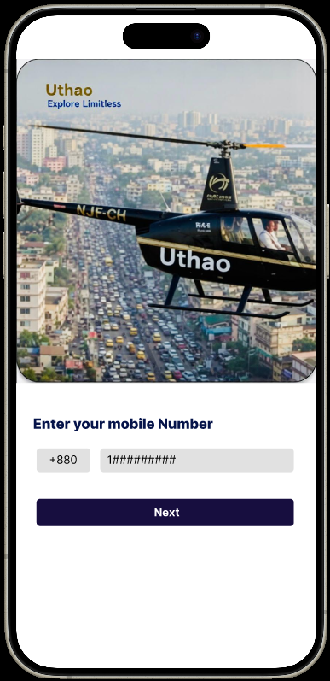

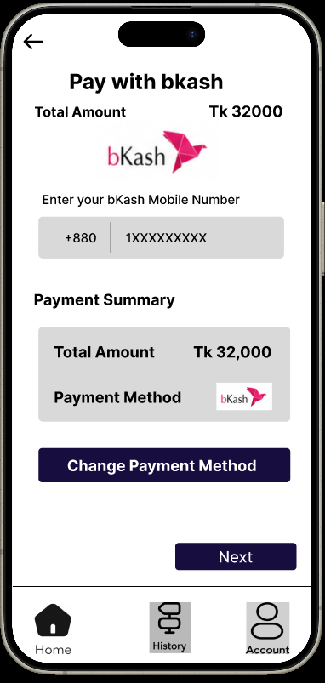
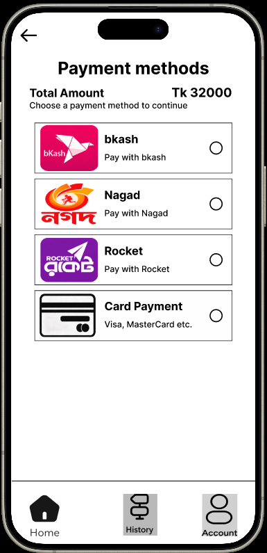
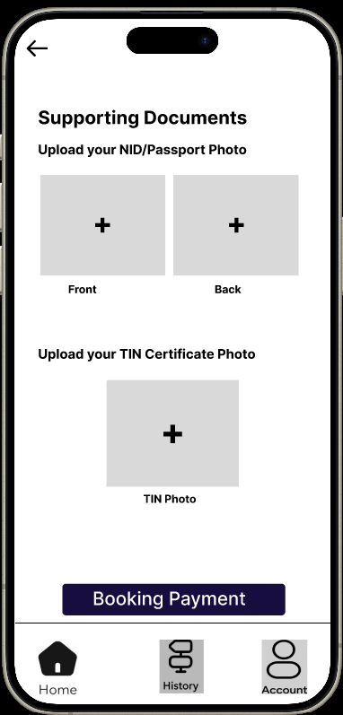

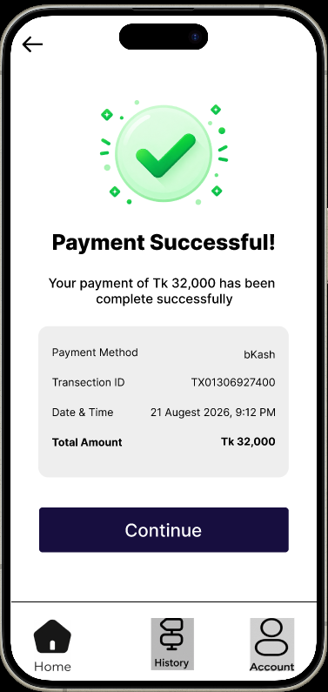
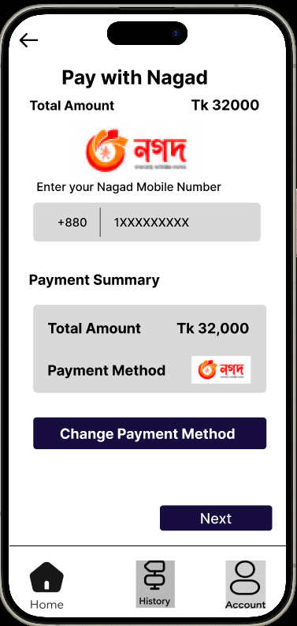

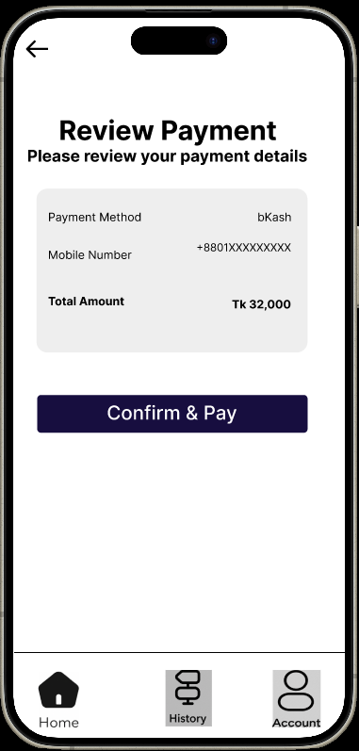
F

